TECHNICAL PROJECT REPORT

# Title of Invention / Project:

Baby Entertainment Arena

# Team Members / Inventors:

|  |  |  |  |  |  |
| --- | --- | --- | --- | --- | --- |
| **S. No.** | **Name** | **Department** | **Designation** | **Mobile** | **E-Mail** |
| 1. | Rup Utpal Paul | ECE | Student | 9775602304 | kittu12paul@yahoo.in |
| 2. | Yogesh Kathuria | ECE | Student | 9711734331 | yogeshkathuria95@gmail.com |
| 3. | Khushal Thakur | ECE | Mentor | 9646030764 | khushal.thakur@cumail.in |
| 4. | Anshul Sharma | ECE | Mentor | 9478697475 | anshulsharma.ece@cumail.in |
| 5. | Kiran Jot Singh | ECE | Mentor | 9463909689 | kiranjotsingh.ece@cumal.in |
| 6. | Divneet Singh Kapoor | ECE | Mentor | 9878422653 | divneet.ece@cumail.in |

Section – 1 (IPR Related)

# Brief Abstract:

The project consists of three battery driven robots that can avoid obstacles. This characteristic of obstacle avoidance has been used at our advantage to place all the three robots in an enclosure so that they can run around here and there and avoid hitting the walls of the arena. The idea is to make a play arena for babies where they’ll be left in the arena along with the robots. The robots will detect the baby as an obstacle and run away from it, and also they will detect each other as obstacles and run away from each other as well.

* Problem

The project is an entertainment based project, it solves the problem of toys hitting each other while operating. The toys detect each other and the obstacles around them using ultrasonic sensors and change their direction accordingly. The toys are pre-programmed to do so. This makes up for a very sophisticated play arena for a baby. The challenge is to keep the baby away from the robot and keep it entertained as well. The robots should also be capable of being efficient in obstacle detection and make turns smartly to avoid bumping.

The robots also need to small in order to be packaged as a toy and also storage of the toy as well as their portability has to be kept in mind.

* Solution

The issue of toys banging onto each other and the obstacles around them is solved using an ultrasonic sensor, the ultrasonic sensor calculates the distance of other toys and obstacles from it. If the distance is lesser than a certain threshold distance the toy changes it direction. After the change in direction the toy also checks further for any obstacles present in its path. If the path is clear the toy moves forward. The issue of keeping the baby and toy apart is also solved by the following method. And for keeping the baby further entertained, LED lights have been installed on the robots which glow when an obstacle is detected.

To make the robot small and portable, a custom chassis was made. Small BO motors and slimmer wheels are used to keep the proportion as small as possible. The pieces are also glued together very firmly as the toy will be fiddled with a lot and it needs to be durable.

* Modification that can be made in the future

Use of LED lights to indicate obstacle detection and also a buzzer or speakers to make the toy more intuitive and engaging. The buzzer could make noised while running away or the speakers can play music while the robots operate. This would improve the entertainment factor of the robot.

# Existing state-of-the-art and Drawbacks in existing state-of-the-art

|  |  |  |
| --- | --- | --- |
| **S. No.** | **Existing state of art** | **Drawbacks in existing state of art** |
| 1 | US Grant US5076520A Jay M. Bro Mattel, Inc. | Existing toys are hit and run toys. They bump into each other and the walls around them, unless their direction is controlled or modified by the user. This causes the toys to wear out quickly, have physical damages and also causes internal mechanical damage |

# Novel/Additional modifications that you can propose to improve upon drawbacks

* Including an ultrasonic sensor for obstacle detection.
* LED lights on the toys to make them more appealing to babies.
* Including a smart microcontroller that can change the distance of the toys on obstacle detection.
* Confining the play area by an arena.

# Advantages

* The toy doesn’t face any physical damage externally or internally due to bumps and collisions.
* The toy also appears to be robotic having a brain of its own to detect obstacles in its path.
* The excitement of toys running away from you keeps them entertained.
* Since there is an enclosed arena, the baby can be left there to play unguarded.

# Block Diagram

A basic block diagram of how the toys are configured and how their parts are going to work in synchronization to each other is given below. The parts that have been used are generic and can be easily found in the market, but in order to improve the product specific parts that have been modified to suit the purpose can be used.

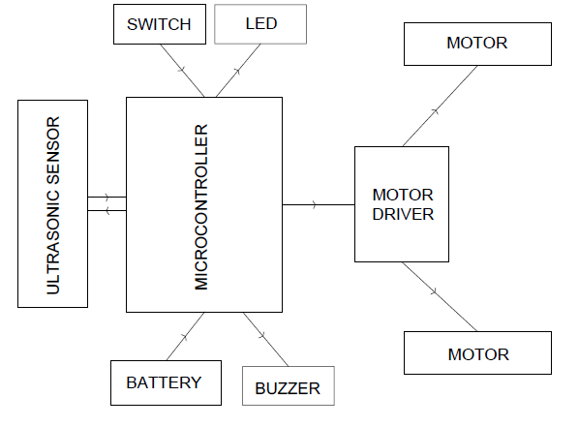

Block Diagram

Section – 2 (Real Project)

# Materials

These are the respective process for materials needed for each robot.

|  |  |  |  |
| --- | --- | --- | --- |
| No. | Item | Specification | Price |
| 1 | Arduino Uno | Atmel 328 Microcontroller | 500 |
| 2 | L929D Motor Driver | L293D Microcontroller | 120 |
| 3 | Ultrasonic Sensor | HCR04 Sensor | 180 |
| 4 | 2BO Motors | 60 RPM motors | 160 |
| 5 | 2Rubberized Wheels | 6 cm wheels | 40 |
| 6 | 1 Caster Wheel | 360 degree metal wheel | 20 |
| 7 | 2 9V Battery | 9V Non rechargeable | 80 |
| 8 | Switch | 3 way slide switch | 10 |
| 9 | Battery Connector | 9V battery connector | 10 |
| 10 | Cardboard Base | Cardboard 5 mm thick | 10 |
| 11 | Jumper Cables | Copper clad cables | 30 |
| 12 | Double Sided Tape | - | 10 |
| 13 | Hot Glue | - | 10 |
| 14 | Connecting wires | - | 10 |
| 15 | Arena | - | 300 |
|  | Total |  | 1200 |

The Total cost of all 3 Robots is 3600 plus the Arena is 300. Grand total of 3900 in expenditure.

Equipment Required

|  |  |
| --- | --- |
| 1 | Soldering Iron |
| 2 | Pliers |
| 3 | Wire Cutters |
| 4 | Hot Glue Gun |
| 5 | Solder Wire and flux |
| 6 | Screw Driver |

# Circuit Diagram

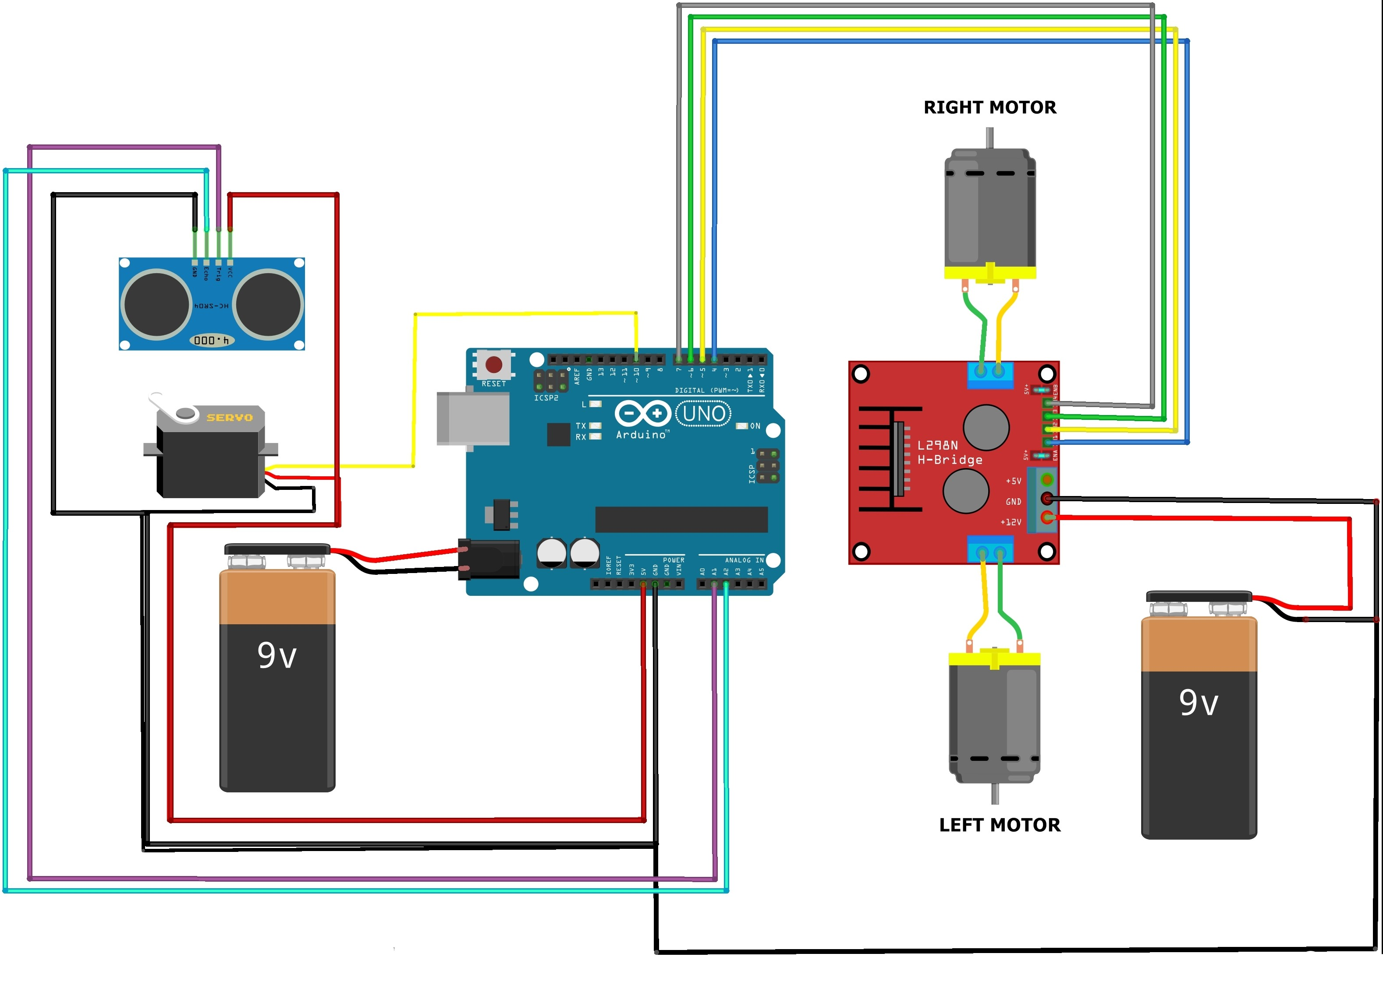

# Steps of Circuit Completion

1. Wires were soldered onto the motors and wheels were attached.
2. The Arduino and motor driver were hot glued on the base
3. Wheels and motor assembly were hot glued on the bottom o the base.
4. The ultrasonic sensor was mounted using a cardboard and hot glue.
5. Batteries fitted with battery connector and the castor wheel were fixed in place using double sided tape
6. The wiring was completed using jumper cables. And a switch was soldered in between the circuit.

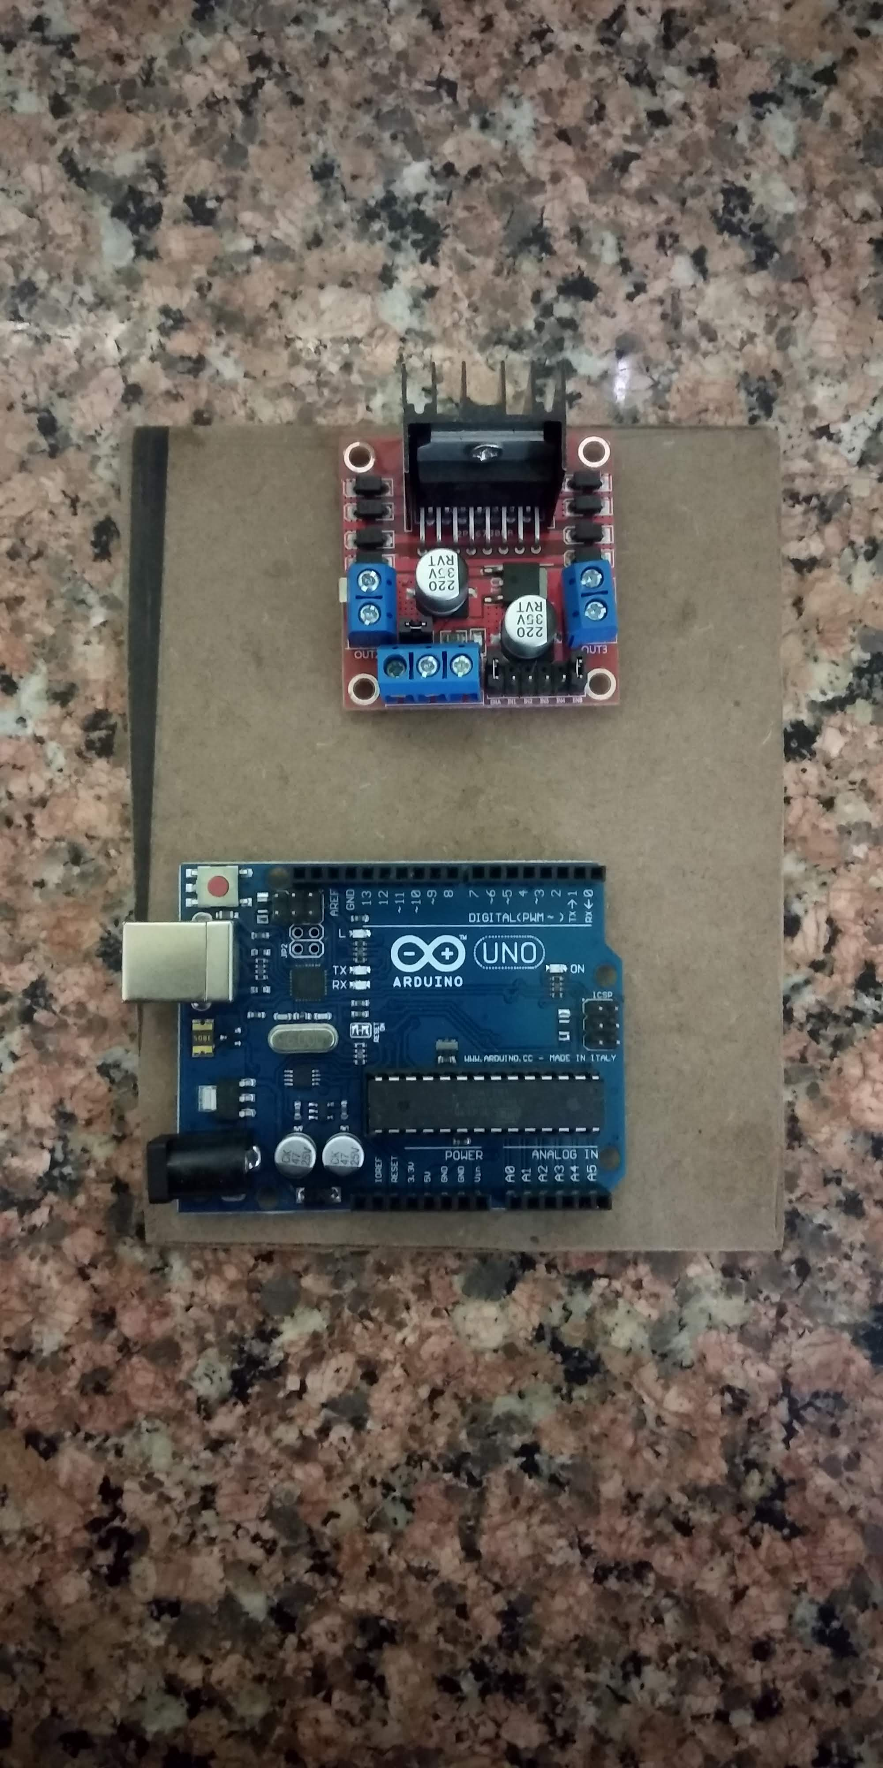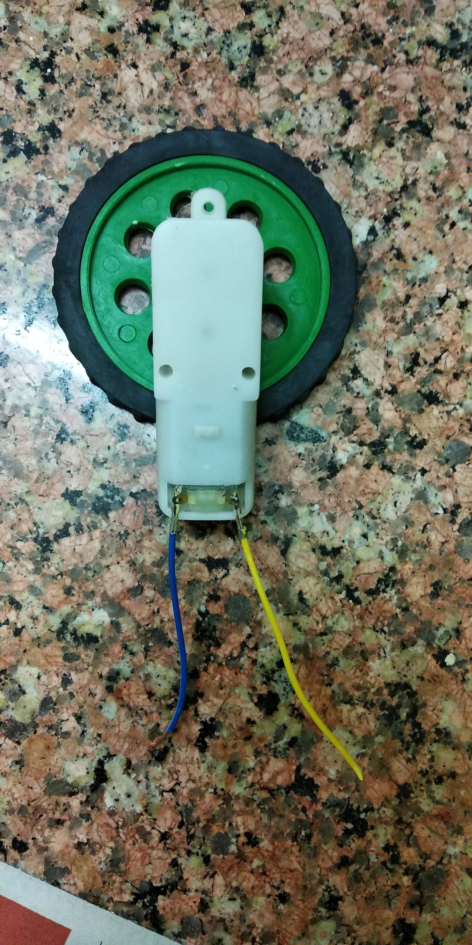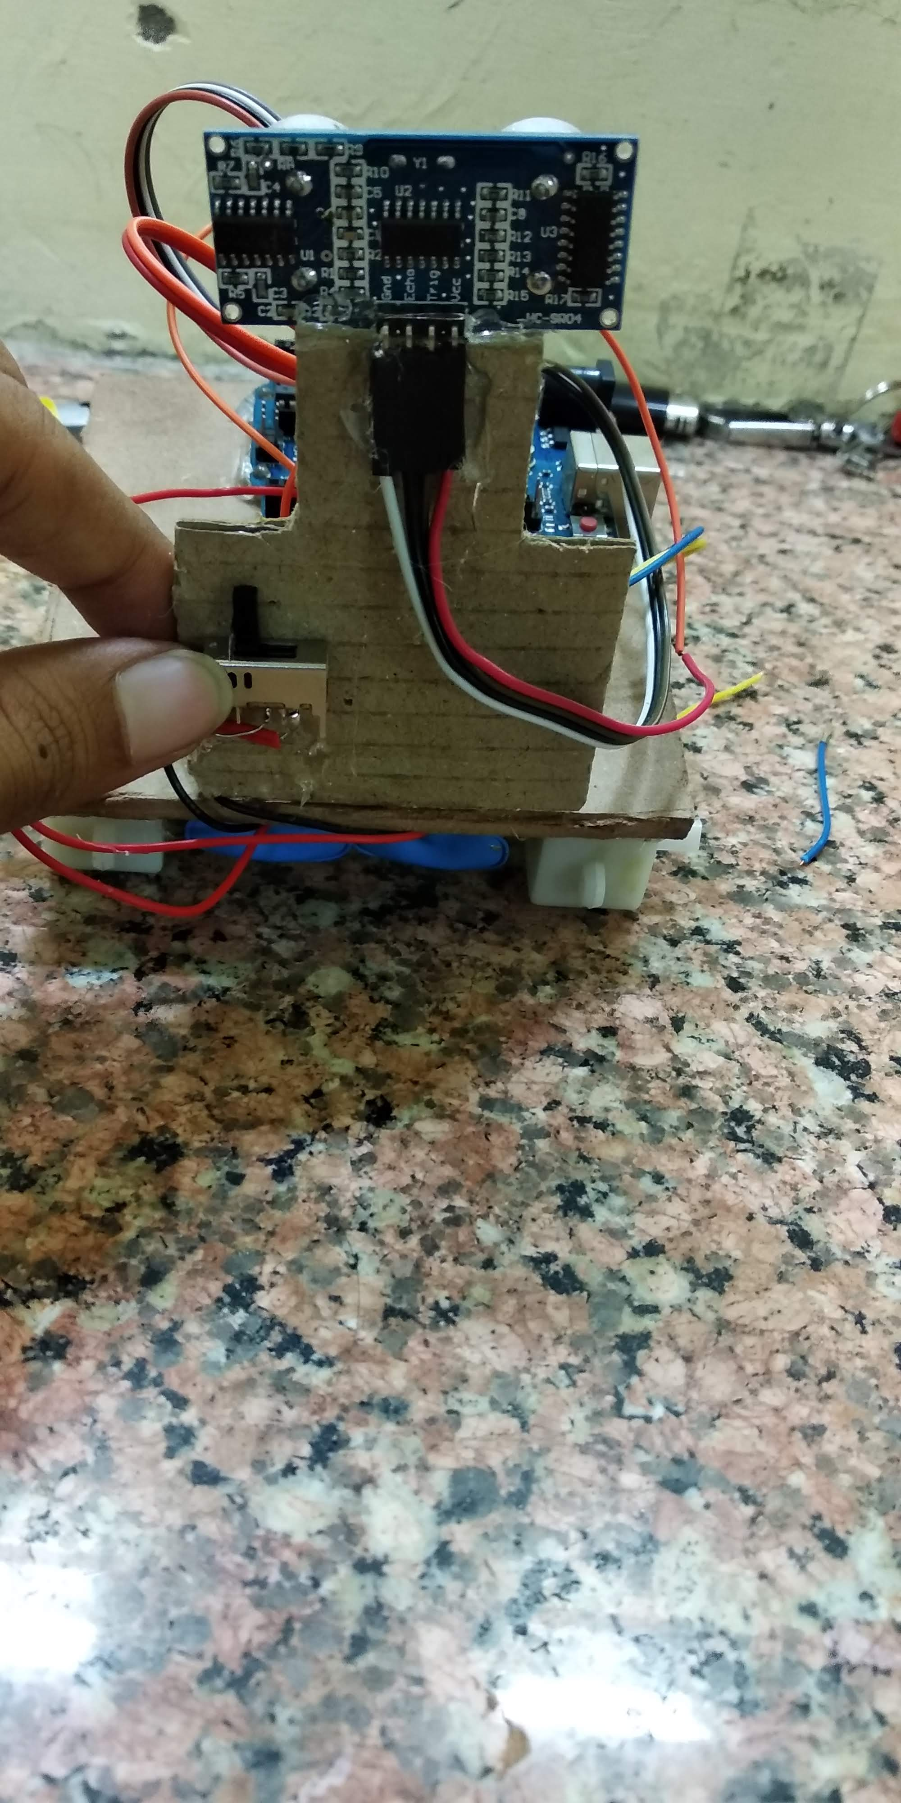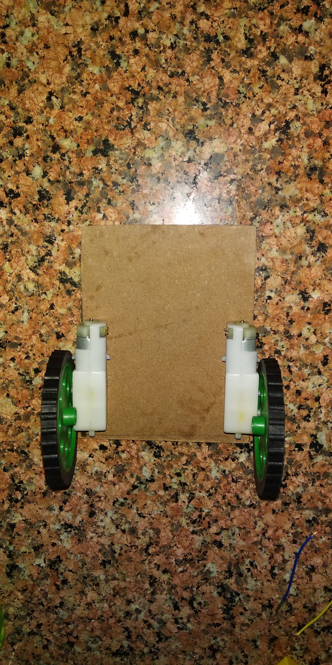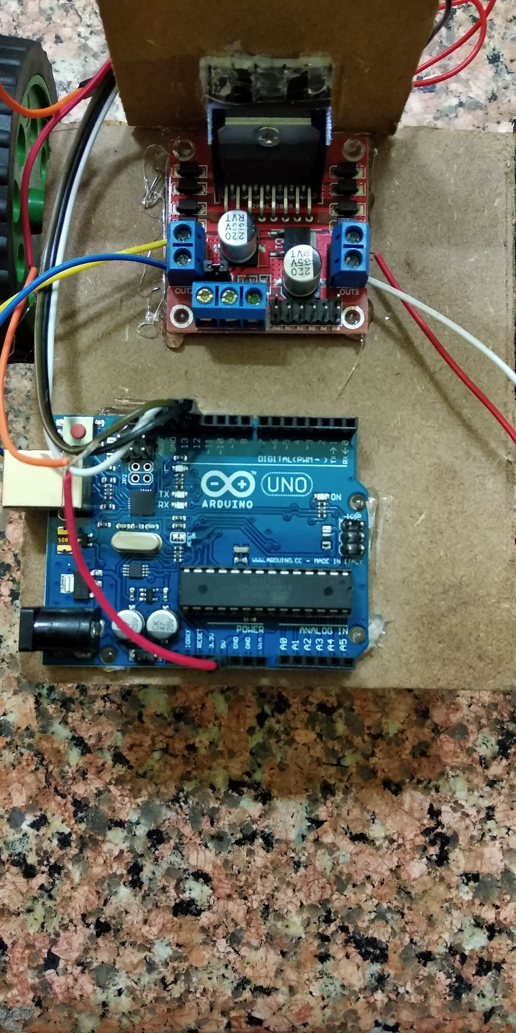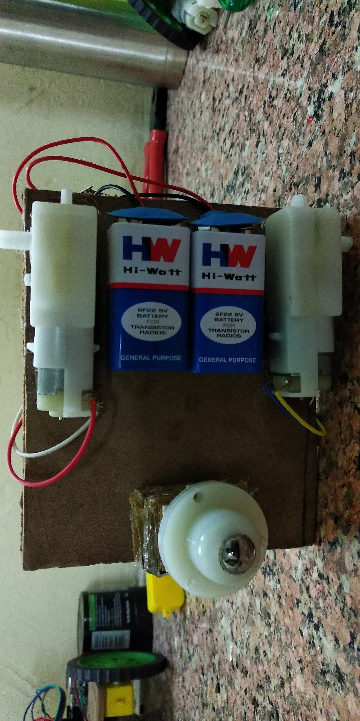

# Program Code

<https://github.com/kittu12paul/Semester-1-ECE-/tree/master>